

**Assessment 3**

**APEX**

Author: Bertocco Thomas-Killian - #13758322

Lecturer: Bahtee Eng

CP5503 Enterprise Database Systems - Oracle | SP53 | 2019

31 January 2020

Table of Contents

Accounts 3

Loan a book 3

Screenshots 5

Improvements 6

The home page 6

More pages 6

Create triggers 6

Create constraints 7

Modify the appearance 7

Overdue report 7

**Important note**: The Oracle APEX support still didn’t accept my request to create the new schema (LIBDB_JC13758322), so I did this assignment on the default schema.

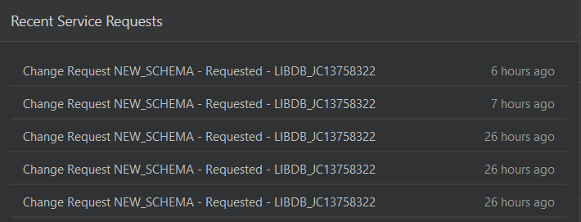

# Accounts

**Admin**: thomaskillian.bertocco@my.jcu.edu.au

Pass : xxx

**Dev**: Jc13758322_dev

Pass: xxx

**User**: Jc13758322_usr

Pass: xxx

# Loan a book

For this task, I followed the tutorial successfully. I had no problems to execute the scripts, create the pages, change the books table columns order, create the field of values and change the type of the “available” column to “link”. I invite you to look at the application online.

## Screenshots

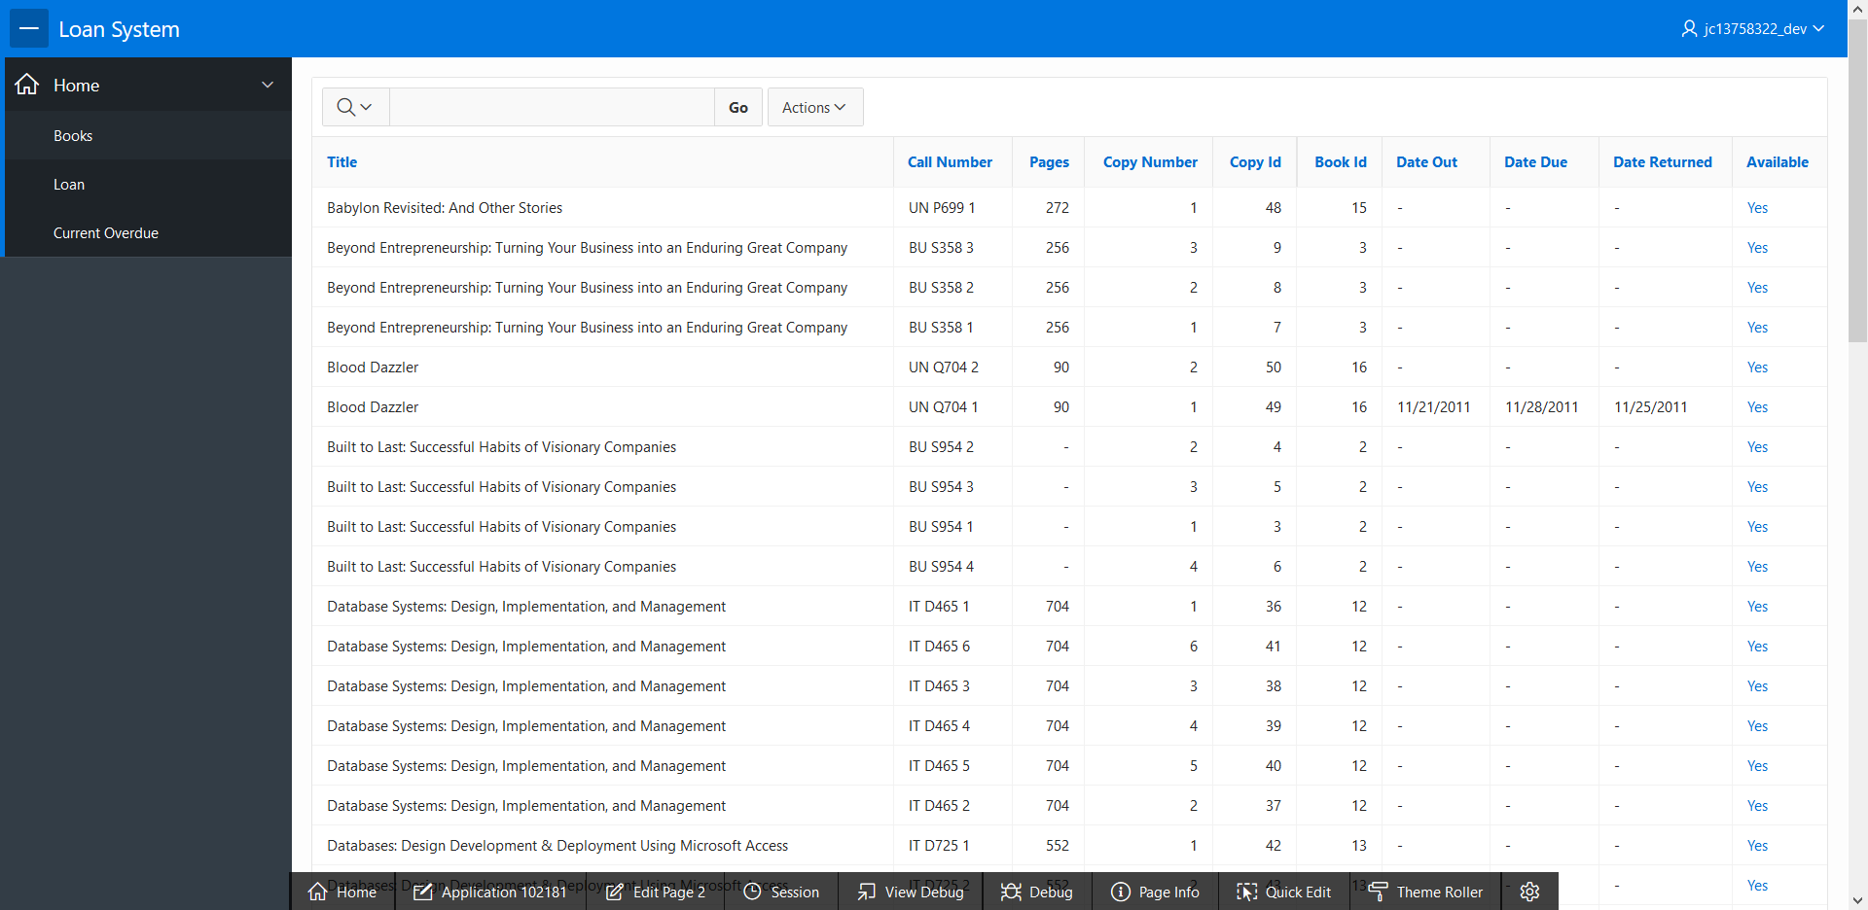

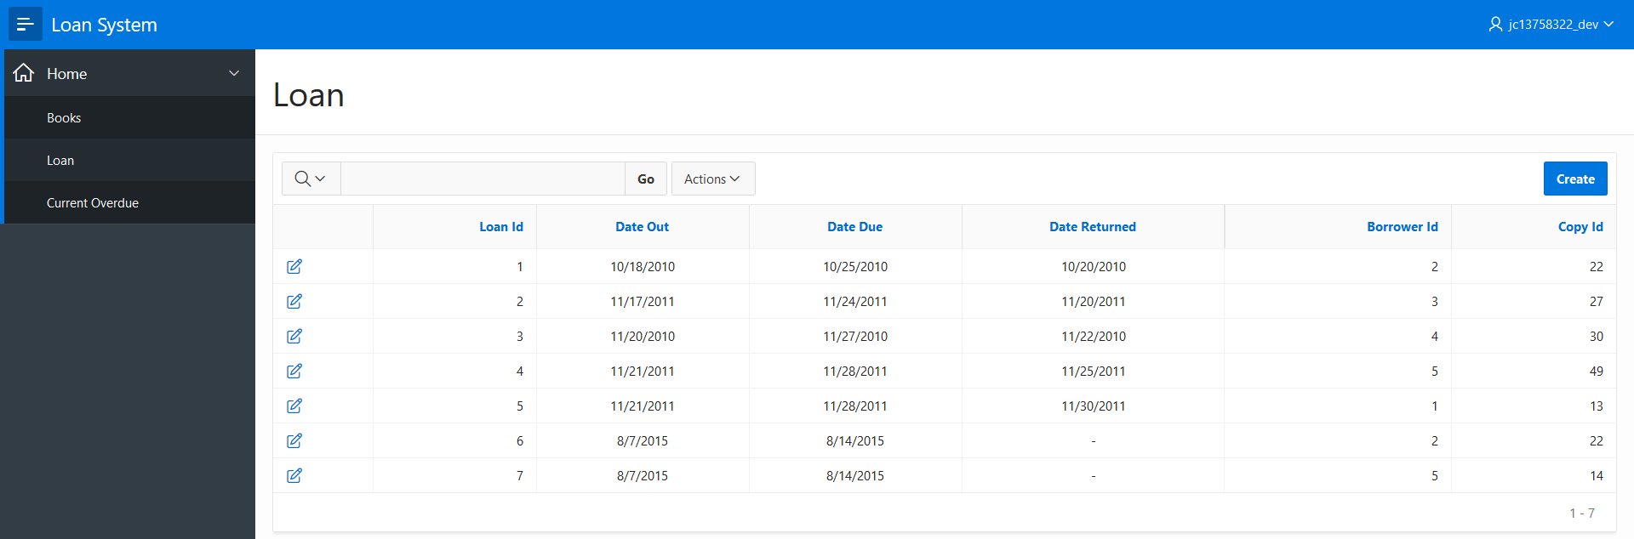

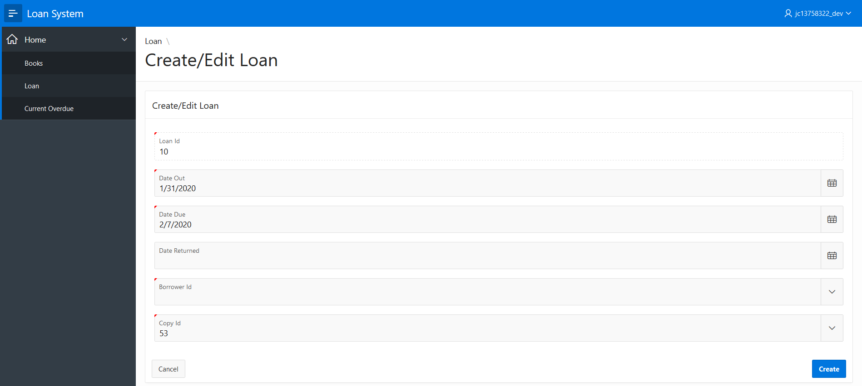

# Improvements

## The home page

The home page of our application is currently empty. We could add title, a logo, information on how to use this application, and the support contact.

## More pages

To make this application complete, we need to create a page that displays the information of a book (resume, writer, …) and another page that displays the borrowers/clients' information (phone, date of creation, name, …).

## Create triggers

We could create triggers to improve data integrity. For example, during the insertion of a new book, we could check the “Call number” field with a regex to verify that it corresponds to the norm. We could also create a trigger/function that prevents the creation of a loan if the borrower already borrowed books without returning them (check overdue list).

## Create constraints

We have to create constraints to improve data integrity. For example, check that the “Call number” field is unique. We also need to create a constraint to check that the “Date due” is superior to the “Date out”, and that the “Date returned” is superior to the “Date due”.

## Modify the appearance

We could modify the style of the application. For example, highlight the available books in green, and the borrowed books in red.

# Overdue report

Concerning the last step, here is my code to create the “Current Overdue” page:

